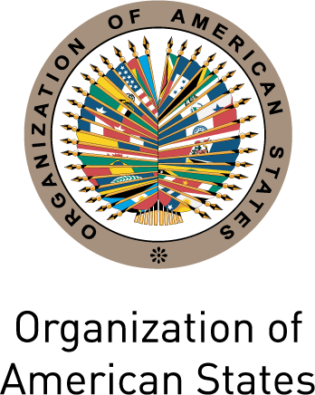
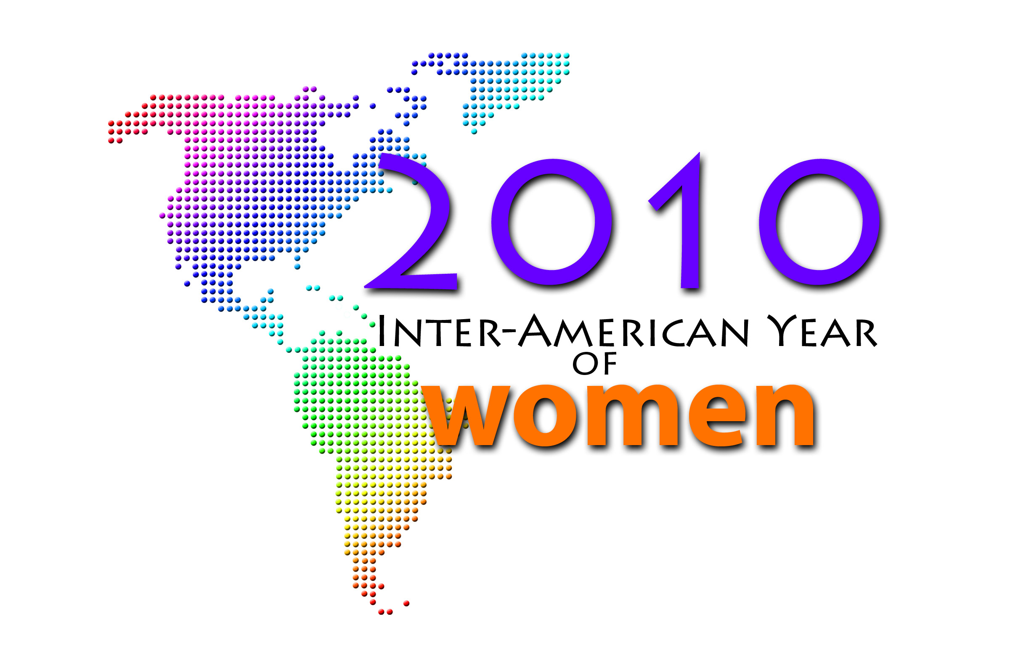

INTER-AMERICAN COMMISSION OF WOMEN

EXECUTIVE COMMITTEE 2008-2010 OEA/Ser.L/II.5.30
THIRD REGULAR SESSION CIM/CD/doc.27/10
February 24 to 26, 2010 26 February 2010
Washington, D.C. Original: Spanish

AGREEMENTS ADOPTED

Place: Simon Bolívar Room (MNB) Date: February 26, 2010
Time: 2:30 to 14:45 hours
Participants:

Executive Committee of the CIM 2008-2010:

Wanda K. Jones, President (United States)
Loretta Butler-Turner, Vice-President (Bahamas)
Ann-Marie Layne, Alternate Delegate (Antigua and Barbuda)
Martha Lucía Vásquez Zawadzky, Principal Delegate (Colombia)
María del Rocío García Gaytán, Principal Delegate (México)

Principal Delegates:

Irene Sandiford-Garner, Principal Delegate (Barbados)
Esther Ayuso Ramirez, Principal Delegate (Belize)
Carmen Andrade Lara, Principal Delegate (Chile)
Mayra Díaz Méndez, Principal Delegate (Costa Rica)
Julia Evelyn Martinez, Principal Delegate (El Salvador)
Sonia Escobedo, Principal Delegate (Guatemala)
Marjory Michel, Principal Delegate (Haïti)
Markelda Montenegro de Herrera, Principal Delegate (Panamá)

Delegations:

Antigua and Barbuda
Deborah–Mae Lovell, Ambassador, Permanent Representative to the OAS

Argentina
Maria Fabiana Loguzzo, Director of Women’s Affairs, Ministry of Foreign Affairs, International Trade, and Worship
Ana M. Pastorino, Counselor, Alternate Representative to the OAS

Bahamas
Phedra M. Rahming, First Assistant Secretary, Officer in Charge of Bureau of Women’s Affairs
Monique Vanderpool, First Secretary, Alternate Representative to the OAS

Barbados
Jane E. Brathwaite, Counselor, Alternate Representative to the OAS
Ricardo Kellman, First Secretary, Alternate Representative to the OAS

Bolivia
Aylin Oropeza, First Secretary, Alternate Representative to the OAS

Brazil
Viviane Rios Balbino, First Secretary, Alternate Representative to the OAS

Chile
Pedro Oyarce, Ambassador, Permanent Representative to the OAS
Lya González, Chief Staff of the Minister of Chile
Maricel Sauterel, Chief, Department of International Relations and Cooperation of the Women’s Affairs Office
Pablo Varas Fuenzalida, Advisor, Department of International Relations and Cooperation of the Women’s Affairs Office
Pamela Albornoz, Alternate Representative to the OAS

Colombia
Sandra Mikan, Second Secretary, Alternate Representative to the OAS

Costa Rica
Zaida Zuñiga, Minister Counselor, Alternate Representative to the OAS
Eduardo José Alfaro Navarro, Advisor of the Executive Presidency of INAMU

Dominican Republic
Alexandra Maldonado, Director of Communications, Ministry of the Women
Dayana Ureña, Counselor, Alternate Representative to the OAS

Ecuador
Maria Cristina Drouet, Permanent Mission of Ecuador

Grenada
Gillian Bristol, Ambassador, Permanent Representative to the OAS
Ingrid Jackson, Alternate Representative to the OAS

Guatemala
Lorena Robles, Director, Social Communication and Public Relations of the SEPREM
Lionel Maza Luna, Ambassador, Interim Representative to the OAS
Elsa Samayoa de González, Third Secretary, Alternate Representative to the OAS

Guyana
Deborah Yaw, Counselor, Alternate Representative to the OAS

Haiti
Suze Percy Filippini, Minister Counselor, Alternate Representative to the OAS

Jamaica
L. Ann Scott, Minister, Alternate Representative to the OAS

Mexico
Patricia Wohlers Erchiga, Alternate Delegate to the CIM, Assistant Director General for International Affairs of INMUJERES
Claudia Gabriela Salas Rodríguez, Director General for Gender Perspective Mainstreaming (INMUJERES)
Héctor Ortega, Second Secretary, Alternate Representative to the OAS

Nicaragua
Julieta Blandón, First Secretary, Alternate Representative to the OAS

Panama
Menitza Mandiche, Second Secretary, Alternate Representative to the OAS

Paraguay
Claudia Medina, Permanent Mission of Paraguay

Peru
Aura Quiñones, Vice-Minister of Social Development, Ministry of Women and Social Development
Giancarlo Gálvez, Second Secretary, Alternate Representative to the OAS

Saint Kitts and Nevis
Gail Gilbert, Alternate Representative to the OAS

Saint Lucia
Clenie Greer-Lacascade, Alternate Representative to the OAS
Saint Vincent and the Grenadines
La Celia A. Prince, Ambassador, Permanent Representative to the OAS

Suriname
Michiel Glenn Raafenberg, Counselor, Alternate Representative to the OAS

Trinidad and Tobago
Frances Seignoret, Counselor, Alternate Representative to the OAS

United States of America
Irene Marr, Office of Global Women’s Issues, United States Department of State
Gianni Paz, Alternate Representative to the OAS

Uruguay
María del Luján Flores, Ambassador, Permanent Representative to the OAS
Graziella Reyes, Minister, Alternate Representative to the OAS

Venezuela
Tereza Arreaza, Counselor, Alternate Representative to the OAS

Permanent Observer Mission

Paloma Temiño, Permanent Observer Mission of Spain

Invited Speakers

Natalia Gherardi, Consultant of the Latin-American Team on Justice and Gender (ELA), Argentina
Juan Manuel Sotelo, Manager, Area of External Affairs, Resource Mobilization and Partnerships (PAHO)
Andrew Morrison, Chief, Gender and Diversity Unit, Inter-American Development Bank
Colette Lespinase – Coordination of the Groupe d’Appui aux Rapatries et Refugies (GARR), Haïti
Elvire Eugene – Organisation AFASDA (Association des femmes soleil d’Haïti)
David C. Hatch, Deputy Director General of IICA
Jimmie Briggs, Executive Director, Man Up, USA

Other Invited

Pan American Health Organization (PAHO)
Marijke Velzeboer-Salcedo, Coordinator, Gender, Ethnicity and Health
Hugo Prado, Senior Advisor, International Cooperation
Priscila Rivas, Senior Advisor, External Relations
AGREEMENTS

The Executive Committee at its Third Regular Session, held on Friday, March 26, 2010 adopted the following agreements:

Agreement No. 1 To approve the Summary Minutes of the Second Regular Session of the Executive Committee (document CIM/CD/doc.20/10).

Agreement No. 2 To approve the Budget Execution as of December 31, 2009 (document CIM/CD/doc.25/10).

Agreement No. 3 To request the OAS Secretary General to:

a. Establish a “Gender Commission,” composed of one representative of each of the organs, agencies, and entities of the OAS, for the purpose of coordinating measures for, and the process of, gender mainstreaming within the Organization, and whose Technical Secretariat will be the CIM; and

b. Consider establishing a monitoring system “Gender Observatory” within the OAS, under the CIM, to follow up on compliance with gender mainstreaming mandates within the Organization.

Agreement No. 4 To request that the Executive Secretariat, in preparation for the Thirty-fifth Assembly of Delegates (Mexico, November 2010) and bearing in mind the results of the evaluation of the IAP and agreements 3.a and 3.b, prepare a proposal for strengthening the Program, in order to strengthen the CIM as a hemispheric policy forum and ensure gender mainstreaming in the OAS work areas.

Agreement No. 5 To approve the Draft Agenda for the Thirty-fifth Assembly of Delegates of the CIM (CIM/doc.17/10 rev. 2).

Agreement No. 6 To approve November 9 to 11, 2010, as the dates for the Thirty-fifth Assembly of Delegates of the CIM, in Mexico City.

Agreement No. 7 To request that the Executive Secretariat, taking into account the current needs of the CIM, prepare a proposal for amendment of the CIM legal instruments in order to submit them to the Delegates for consideration and to present the results to the Thirty-fifth Assembly of Delegates.

Agreement No. 8 To request the Technical Secretariat of the MESECVI to:

a. Submit the Questionnaire on Evaluation to the Competent National Authorities and invite them to respond at their earliest convenience; and

b. Based on the results of the evaluation, prepare a proposal for strengthening of the MESECVI, to be presented for analysis and adoption at the next Conference of States Parties (Guatemala 2010).

Agreement No. 9 To post on the OAS and CIM Websites a disclaimer stating that the opinions expressed by the panelists during the launching of the Inter-American Year of Women do not necessarily represent the views of the OAS, its member states, or the Delegates to the CIM.

Agreement No. 10 To request the OAS Secretary General to present the “Declaration of Solidarity with the Women of Haiti,” adopted at the Special Session of the CIM Executive Committee on February 26, 2010, in Washington, D.C., to the World Summit for the Reconstruction of Haiti, to be held in the Dominican Republic on June 2, 2010.
input.doc

Agreement No. 11 To request the Secretary General to:

a. Incorporate in his Plan of Action for 2010–2015, to be presented to the OAS Permanent Council on March 3, the Empowerment of Women and Gender Equality” as a lynchpin for the consolidation of democracy as promoted by the Organization; and

b. Continue promoting gender mainstreaming in OAS strategic definitions throughout the inter-American system. Likewise, ensure that budget allocations to the CIM are increased.

